CS 255 System Design Document
Southern New Hampshire University
Professor Federico Bermudez
Thoura Chris Ouk
Project 2
Southern New Hampshire University

UML Diagrams

UML Use Case Diagram
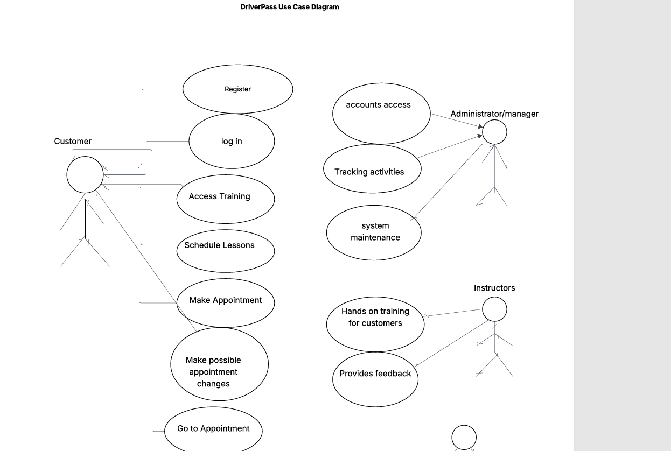

UML Activity Diagrams
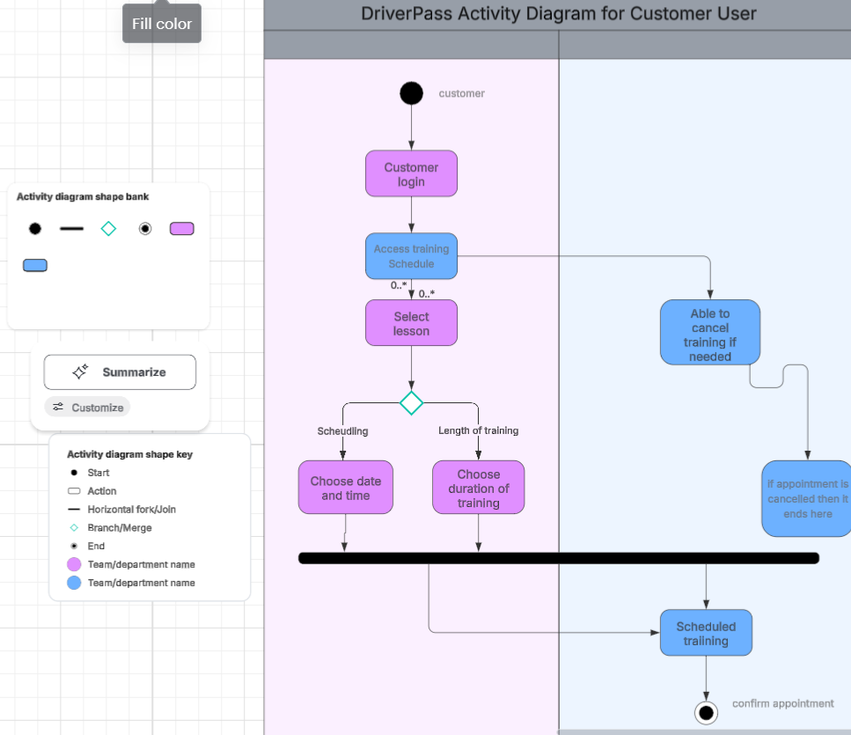

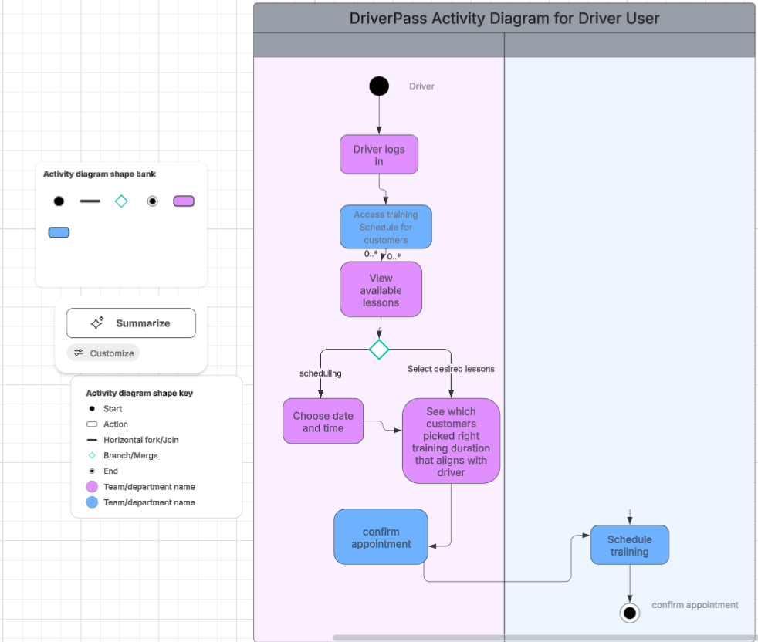

UML Sequence Diagram

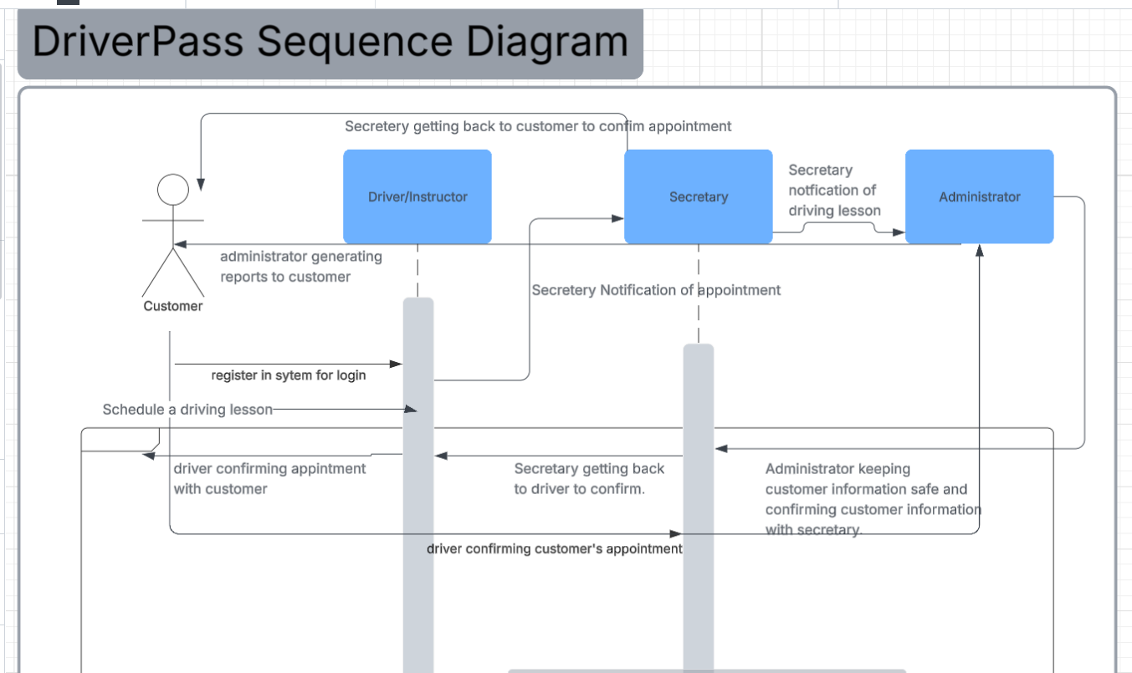

UML Class Diagram

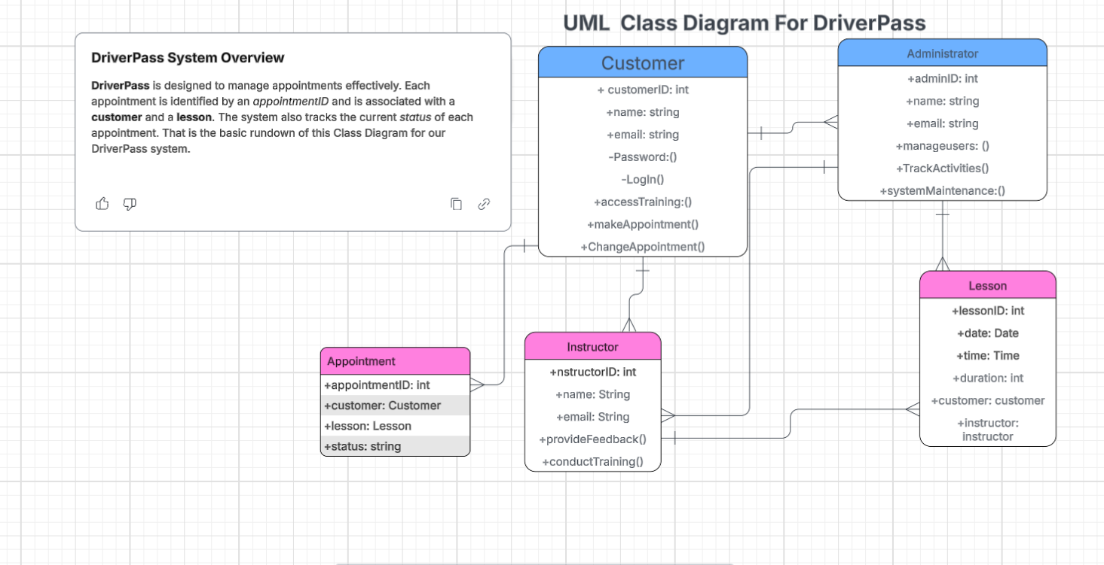

Technical Requirements
Based on the requirements of the DriverPass system, we would recommend the following technical requirements:

- Hardware Requirements
- Server
- Client devices
- Software Requirements
- Application software
- Database Management system
- Front-End Technologies
- Development Tools
- Testing tools
- Infrastructure Requirements
- Web hosting
- Network requirements
- Backup and recovery
- Tools
- Development of tools
- Testing tools

The server needs something like a cloud-based application. It would need a minimum processor, RAM and storage. This is part of the hardware requirements. Client Devices would consist of desktops, laptops, tablets, and mobile devices.

Software requirements would consist of web applications developed in a suitable programming language such as Java, Python, JavaScript or C++. We would use more programming languages for front-end technologies. Such as HTML, CSS, and JavaScript.

Infrastructure requirements might consist of needing a reliable web hosting service. Something like Options for cloud hosting providers would work. We would also need a reliable web hosting service for this part of the requirement. Along with high-speed internet connection and a backup and recovery system.

These requirements would tell us the basic outline of the necessary components for developing and maintaining the DriverPass system.

